**Guess number**

Step 1: import the component and create an def guess number:

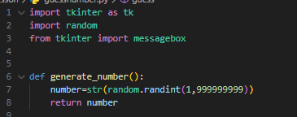

Step2 :design the tkinter element

Step 3: create a def the check the guessing number

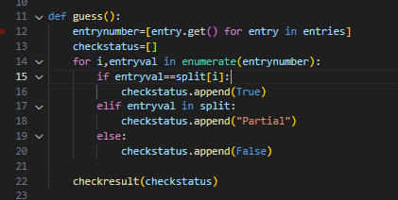

Here the finale result:

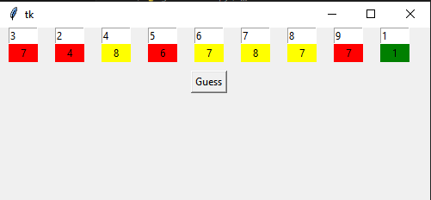

Here the sample code:

**import tkinter as tk**

**import random**

**from tkinter import messagebox**

**def generate_number():**

**number=str(random.randint(1,999999999))**

**return number**

**def guess():**

**entrynumber=[entry.get() for entry in entries]**

**checkstatus=[]**

**for i,entryval in enumerate(entrynumber):**

**if entryval==split[i]:**

**checkstatus.append(True)**

**elif entryval in split:**

**checkstatus.append("Partial")**

**else:**

**checkstatus.append(False)**

**checkresult(checkstatus)**

**def checkresult(checkstatus):**

**if all(checkstatus):**

**messagebox.showinfo("Congratulations","You guessed the number!")**

**for i,status in enumerate(checkstatus):**

**tk.Label(root,text=split[i],bg="green").grid(row=1,column=i,sticky="nsew",padx=10)**

**else:**

**messagebox.showinfo("Sorry","You did not guess the number. Try again!")**

**for i,status in enumerate(checkstatus):**

**if status==True:**

**tk.Label(root,text=split[i],bg="green").grid(row=1,column=i,sticky="nsew",padx=10)**

**elif status=="Partial":**

**tk.Label(root,text=split[i],bg="yellow").grid(row=1,column=i,sticky="nsew",padx=10)**

**else:**

**tk.Label(root,text=split[i],bg="red").grid(row=1,column=i,sticky="nsew",padx=10)**

**random_number=generate_number()**

**split=list(random_number)**

**root=tk.Tk()**

**root.geometry("500x200")**

**entries=[]**

**for i,digit in enumerate(split):**

**# print(enumerate(split))**

**entry = tk.Entry(root, width=5)**

**entry.grid(row=0,column=i,sticky="nsew",padx=10)**

**entries.append(entry)**

**# print(entries)**

**button=tk.Button(root,text="Guess",command=lambda:guess()).grid(row=2,column=0,sticky="n",padx=20,pady=10,columnspan=len(split))**

**root.mainloop()**